“**Here’s a more detailed explanation of the steps your sister can follow to implement the improvements you need for your dynamic blog and project portfolio. I’ll break down each part with explanations and examples:**”👇🏾

### **1. Adding a WYSIWYG Editor for Text Formatting**

#### **What is a WYSIWYG Editor?**

A **WYSIWYG** (What You See Is What You Get) editor allows you to see the final output while you are editing, like popular tools such as **WordPress** or **Google Docs**.

#### **Steps:**

1. **Install a WYSIWYG Editor (like TinyMCE or CKEditor)**:
   * Your sister can include a **JavaScript-based WYSIWYG editor** into the text acceptor field of the admin panel.
   * Example (TinyMCE):

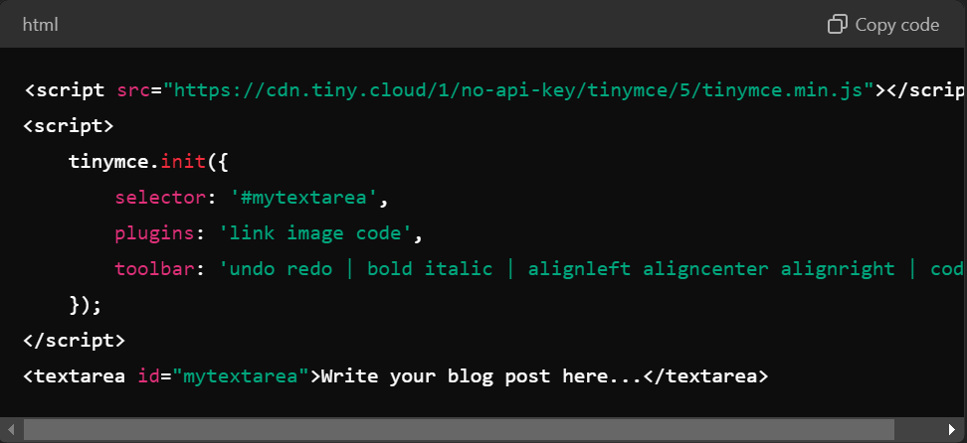

* + This will transform your simple text input into a full-featured editor where you can format text, add links, images, etc.

#### **Example:**

* Instead of pasting raw text, you’ll be able to format your blog post like:
  + Headings
  + Bold/Italic text
  + Lists (bullet points)
  + Code blocks

#### **Backend Setup:**

* When you hit "Submit" from the admin panel, the content (HTML format) is saved in the database and will appear formatted properly on the blog.

### **2. Setting Up Dynamic Project Detail Pages**

#### **Objective:**

When a user clicks on a project image, they should be taken to a detailed project page with more information, images, and embedded videos.

#### **Steps:**

1. **Create a Project Model in the Database**:
   * Each project should have a unique ID, title, description, images, and an optional YouTube video link.
   * Example (in **MySQL** or any other database):

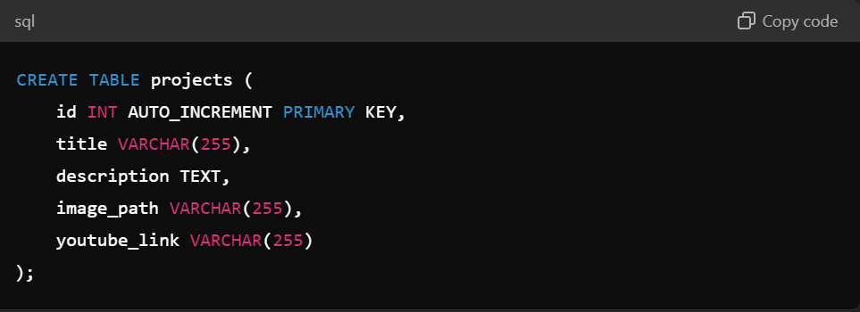

**Admin Interface for Adding Projects**:

* Your sister can create a form where you can input the project details and upload images.
* Example:

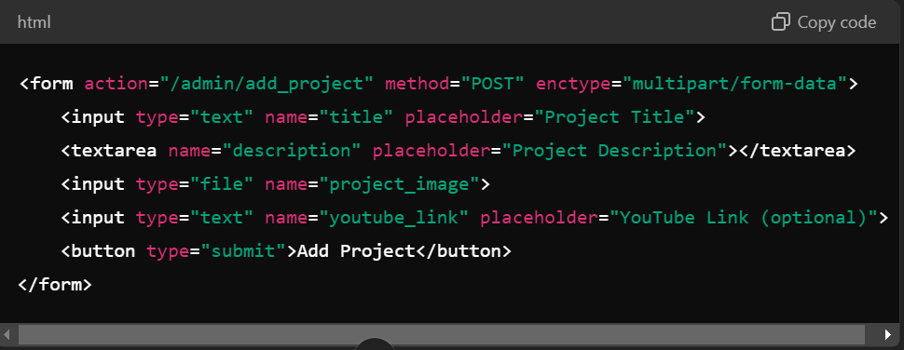

**Link Project Boxes to Detailed Pages**:

* When displaying your projects on the portfolio, the project box can link to a detailed page using the project’s unique ID.
* Example (for displaying project boxes):

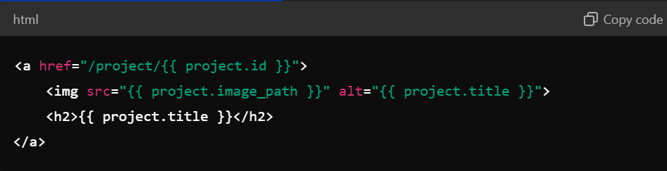

**Create a Detailed Project Page**:

* When a user clicks on a project, they are taken to a detailed page. This page shows the project description, images, and YouTube video (if provided).
* Example (Project Detail Page):

<div>

<h1>{{ project.title }}</h1>

<p>{{ project.description }}</p>

<img src="{{ project.image_path }}" alt="{{ project.title }}">

{% if project.youtube_link %}

<iframe width="560" height="315" src="https://www.youtube.com/embed/{{ project.youtube_link.split('=')[1] }}" frameborder="0" allow="accelerometer; autoplay; encrypted-media; gyroscope; picture-in-picture" allowfullscreen></iframe>

{% endif %}

</div>

### **Embedding YouTube Videos into Project Pages**

#### **Objective:**

You want to embed a YouTube video in your project pages that show how you made the project.

#### **Steps:**

1. **Allow Adding YouTube Links in Admin**:
   * Your sister can create a field in the admin panel where you can paste the YouTube link.
   * Example (in the admin form):

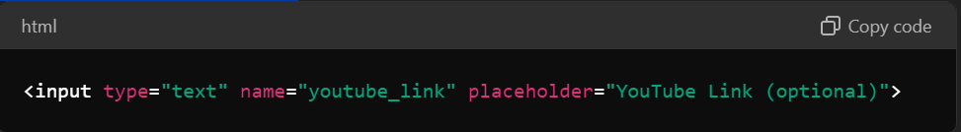

**Embed the YouTube Video**:

* On the detailed project page, if the youtube_link field is filled, she can use an iframe to embed the video.
* Example:

{% if project.youtube_link %}

<iframe width="560" height="315" src="https://www.youtube.com/embed/{{ project.youtube_link.split('=')[1] }}" frameborder="0" allow="accelerometer; autoplay; encrypted-media; gyroscope; picture-in-picture" allowfullscreen></iframe>

{% endif %}

// The split('=')[1] extracts the video ID from a standard YouTube URL, so you can embed it.

### **4. Final Blog and Project Setup**

#### **Blog Post Example (Final Output):**

* After using the WYSIWYG editor, a blog post could look like this:

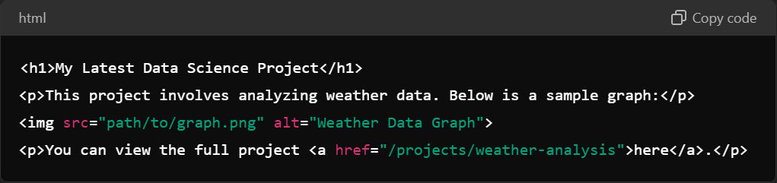

#### **Project Page Example:**

* A detailed project page with a YouTube video embedded might look like:

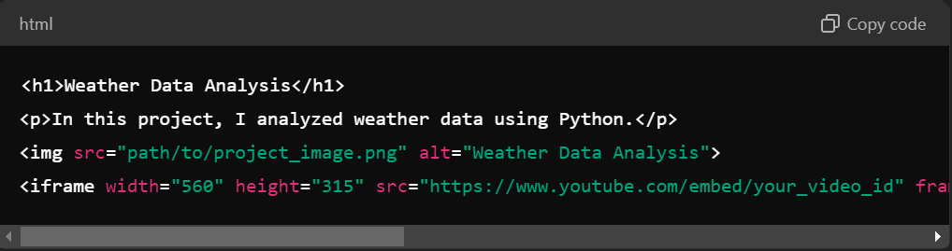

### **Additional Tips:**

* **Responsive Design**: Ensure that the content (images, text, and videos) is responsive and looks good on mobile and desktop screens. CSS frameworks like **Bootstrap** can help with this.
* **Preview Feature**: Adding a "preview" option in the admin panel can allow you to see how a post or project will look before publishing.

By following these steps, your blog posts and project pages will be displayed in a neat, organized, and visually appealing manner! Let me know if any part needs more explanation.